### Author

BALASURYA K

22f3002744

22f3002744@ds.study.iitm.ac.in

I am a fulltime BS data science student at IIT Madras. I like to develop web pages, analyse data using machine learning algorithms. I wish to pursue my career as a Data scientist.

### Description

This project mainly focuses on two sets of users, Listeners who listen to all the songs, read lyrics, listen to songs under albums, rate songs, create playlists of existing songs and listen to the songs in the order they wish. Followed by the creators who upload all the songs, albums, lyrics and edit when required.

### Technologies used

Flask framework-Used to create end points

Flask login-Handles all logins and Login Manager for storing the logged user.

Flask_sqlalchemy-To create/edit database and query the database.

Bootstrap-For HTML and CSS templates

Matplotlib-For creating graphs for admin dashboard.

### Architecture and Features

The structure of file is as follows:

1. app.py is in the root folder (this file should be executed).
2. Static folder contains CSS file and audio folder which saves the song data.
3. Instance folder save the SQLite database.
4. Templates folder contains all Html files.

Features are as follows:

1.Listen to existing songs, rate/comment songs as user.

2.Create playlist of existing songs.

3.Upload song/lyrics, create genre, as a creator.

4.Create new albums and assign songs to the albums.

5.Edit/Delete the songs/albums Which you have created.

6.Admin view has privilege to flag/remove song and blacklist creator.

### DB Schema Design

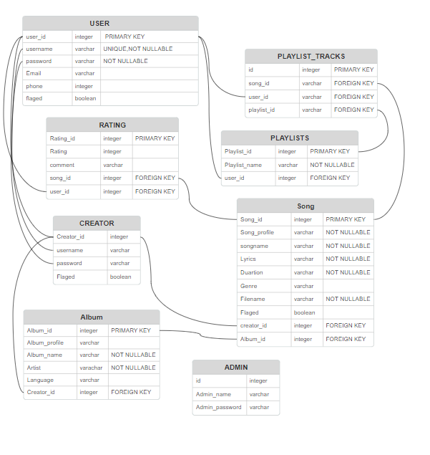

### Video

The video link is below:

https://drive.google.com/file/d/1hBVYg_gKqUrP47BOGof7oQI0rHXi2Xmn/view?usp=drive_link